DAY 1

ls : list command

cd : Change directory command

mkdir : Create a Directory command  
rmdir : remove an empty directory  
rm -rf directory_name : remove a directory with contents

touch : create a blank file   
echo : to add input to a file   
echo “file_content” > file_name : to create a file with content in it   
printf : to print the content into a file   
nano : to edit a file in nano editor  
vi : to edit a file in vi editor  
mv : to move the contents of a file or folder to another folder  
cp : to copy the contents of a file or folder to another file or folder  
cp -r : to copy the contents of a folder to another folder  
cat : to print the contents of a file or folder   
history : to print the history of commands used   
history > out.txt : to save the history into a file as input  
  
“>” : this allows to add something from source to destination but the destination is overwritten with the contents of3e source  
“>>” : to overcome the problem of overwriting, we use the double greater than sign This preserves the content of the destination file

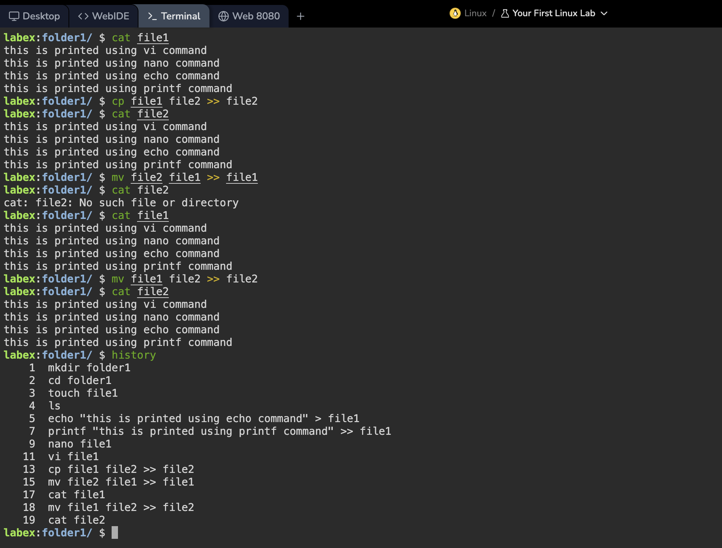

Tasks of the DAY

* Rename one of the files.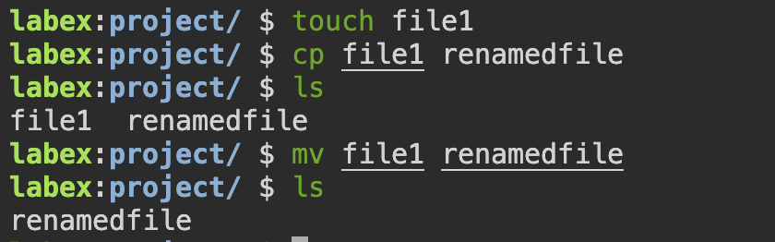
* Create multiple Files in single command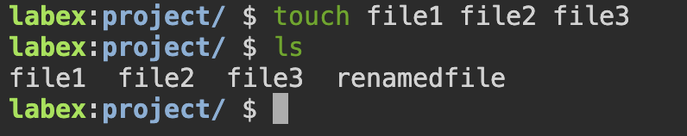
* Combine multiple files in a single command and redirect their output to a single file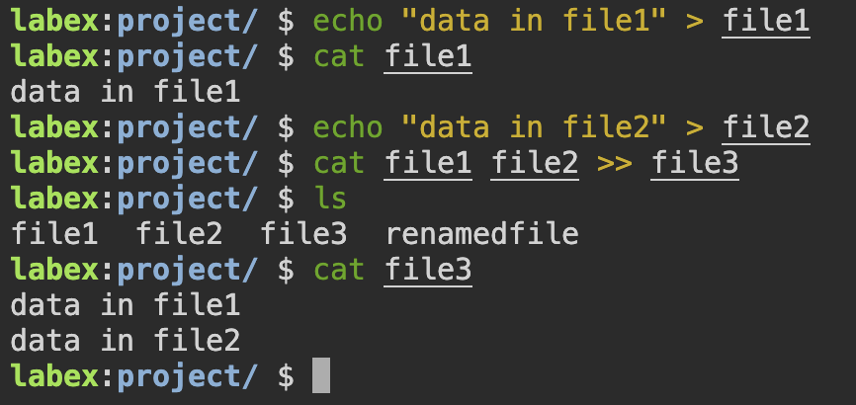
* Create a directory and a few text files in it.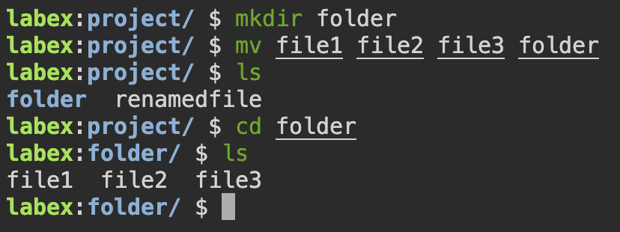

DAY 2

NUMBER SYSTEMS

1. Unary
2. Binary
3. Ternery
4. Octal
5. Decimal
6. Hexadecimal

Hexadecimal:

Representation of numbers using base 10, ranging from 0 to 9

Binary:

Representation of numbers using 2 bits 0 and 1, or base 2

Task: write the range, and representations of bits ranging from 1 to 8

No. series range number of sets

1 0,1 (0 - 1) 2

2 0,1,2,3 (0 - 3) 4

3 0,1,2,3,...7 (0 - 7) 8

4 0,1,2,3,...15 (0 - 15) 16

5 0,1,2,3,...31 (0 - 31) 32

6 0,1,2,3,...63 (0 - 63) 64

7 0,1,2,3,...127 (0 - 127) 128

8 0,1,2,3,...255 (0 - 255) 256

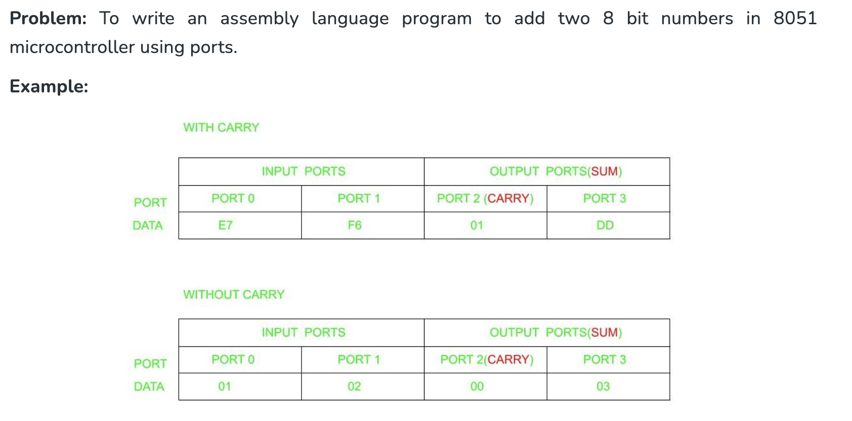

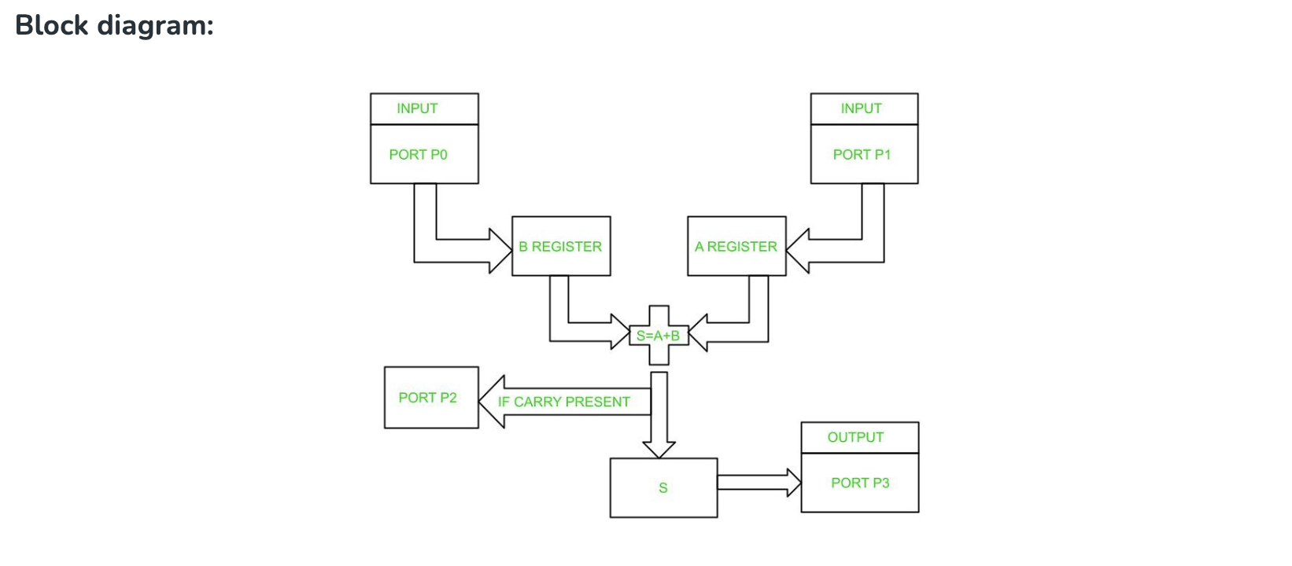

**Algorithm:**

* Initialize Ports P0 and P1 as input ports.
* Initialize Ports P2 and P3 as output ports.
* Initialize the R1 register.
* Move the contents from Port 0 to B register.
* Move the contents from Port 1 to A register.
* Add contents in A and B.
* If carry is present increment R1.
* Move contents in R1 to Port 2.
* Move the sum in step 6 to Port 3.

**PROGRAM**

ORG 00H // Indicates starting address

MOV P0,#0FFH // Initializes P0 as input port

MOV P1,#0FFH // Initializes P1 as input port

MOV P2,#00H // Initializes P2 as output port

MOV P3,#00H // Initializes P3 as output port

L1:MOV R1, #00H // Initializes Register R1

MOV B,P0 // Moves content of P0 to B

MOV A,P1 // Moves content of P1 to A

CLR C // Clears carry flag

ADD A,B // Add the content of A and B and store result in A

JNC L2 // If carry is not set, jump to label L2

INC R1 // Increment Register R1 if carry present

L2: MOV P2, R1 // Moves the content from Register R1 to Port2

MOV P3,A // Moves the content from A to Port3

SJMP L1 // Jumps to label L1

END

Here's an 8051 assembly code example to multiply two 8-bit numbers, with the result stored in 16-bit registers:

; Assume 'num1' and 'num2' are 8-bit numbers stored in memory locations 0x40 and 0x41 respectively

; The 16-bit result will be stored in R2 (low byte) and R1 (high byte)

**PROGRAM**

MOV R0, #0x40 ; Set R0 to point to num1

MOV R1, #0x41 ; Set R1 to point to num2

MOV A, [R0] ; Move num1 into the accumulator(A)

MOV B, [R1] ; Move num2 into register B

MUL AB ; Multiply the contents of A and B,  
 storing the 16-bit result

; (low byte in A, high byte in B)

MOV R2, A ; Store the low byte of the result in R2

MOV R1, B ; Store the high byte of the result in R1

DAY 3

# The commands and codes are taught for the day for linux and shell scripts

ubuntu, centos, rhel, Debian, fedora, kali   
 /home - user files  
 /etc - configuration files  
 /var - logs  
 demons/deamons : authd  
 /usr - prorams (codes)  
 /bin - essentials lib or bin  
 /root -

pwd  
 ls  
 cd  
 cp  
 mv  
 rm  
 touch  
 mkdir  
 cat  
 nano, vim

r4 w2 x1  
 ls -l  
 chmod 741 file1  
 user: gp:others  
 users and groups  
 super user : + - see edit - full access  
 user : x x ? x  
 install  
 sudo useradd user1  
 sudo passwd 12345678  
 switch users : su - user2  
 cat /etc/passwd  
 sudo groupadd gp1  
 sudo usermod -aG gp1 user1  
 Debian/ubuntu  
 apt update && apt upgrade  
 apt install  
 rhel/centos:  
 yum update  
 yum install package

**Shell Scripting Tasks**

**Create a sum program with shell scripting**

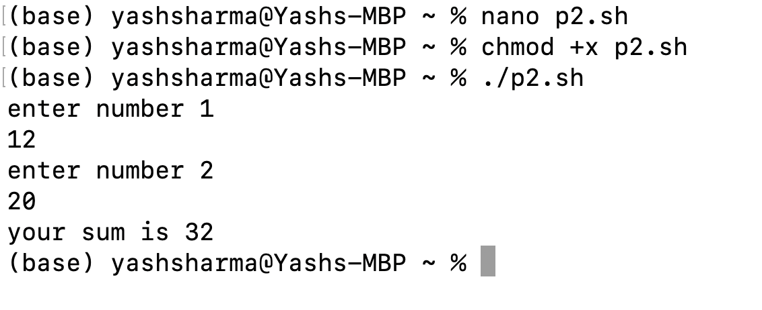

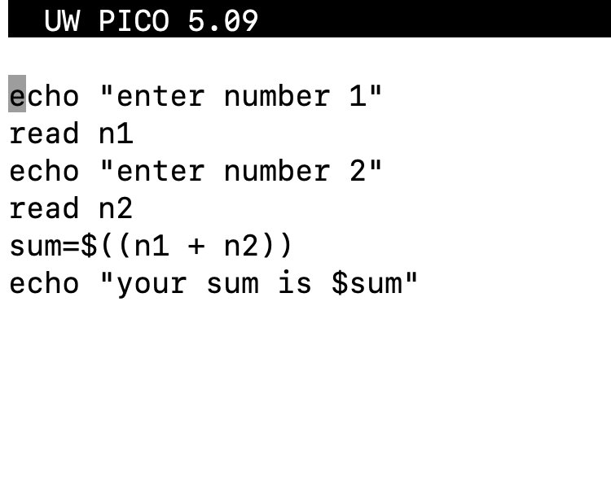

**Create a Less than and greater than program  
  
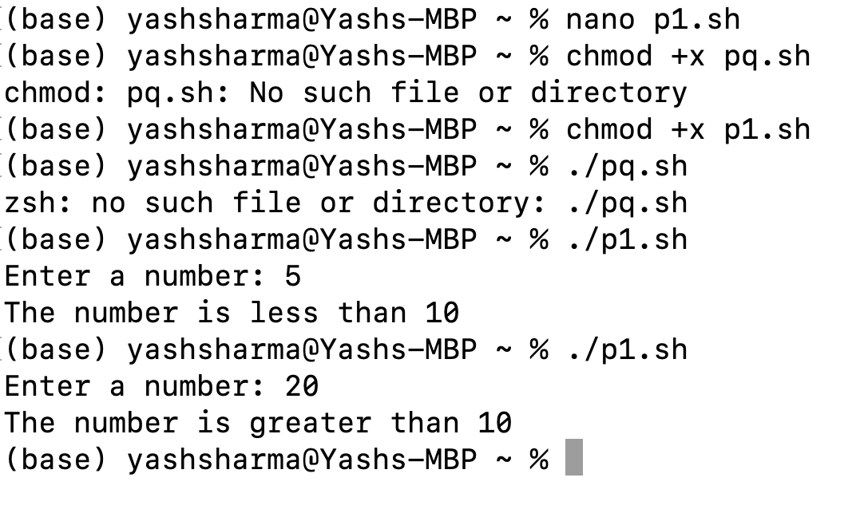**

**Code**

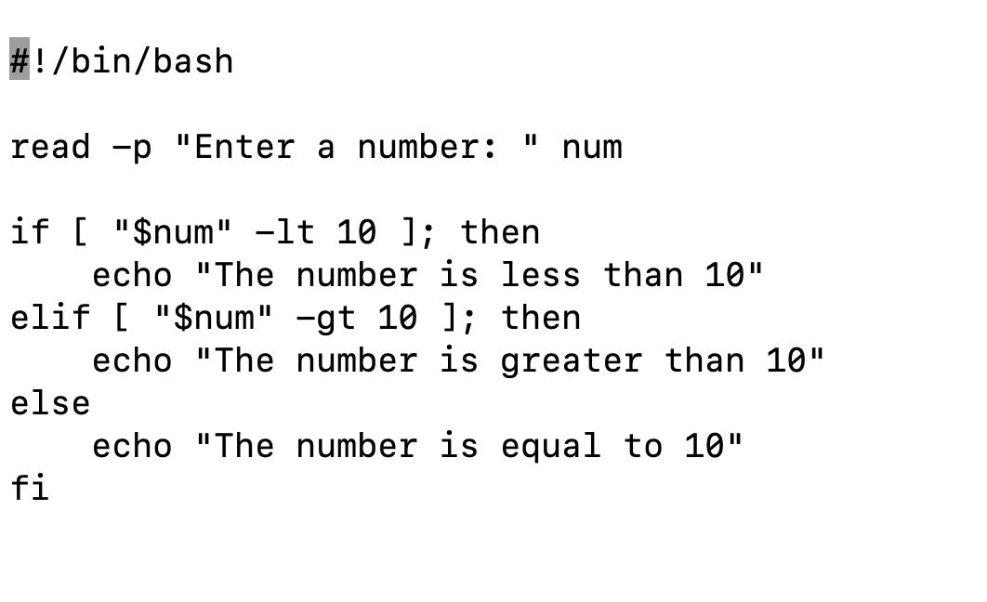

**Create a calculator in shell scripting**

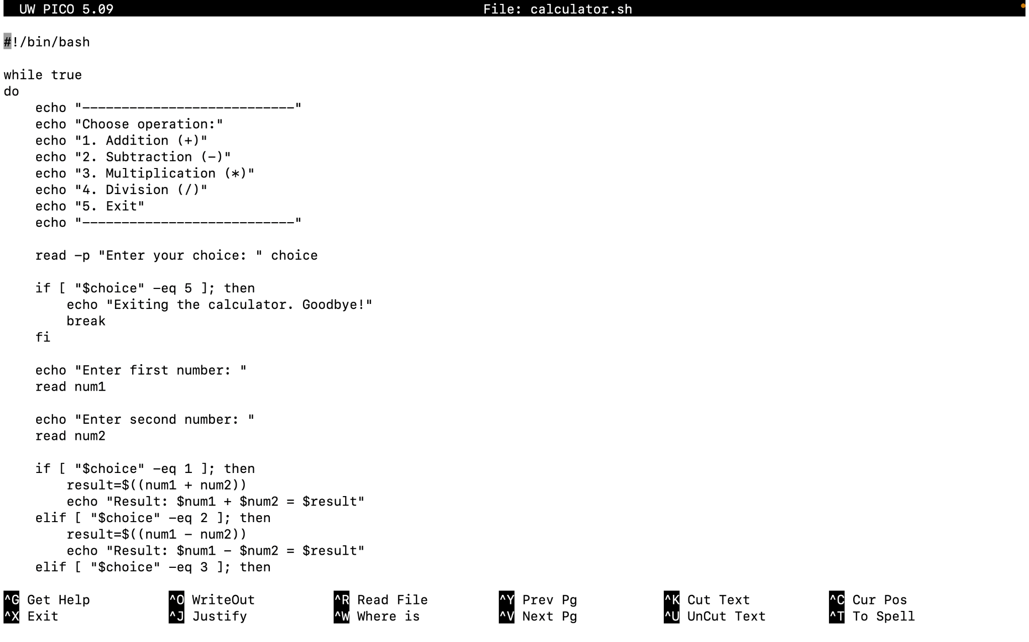

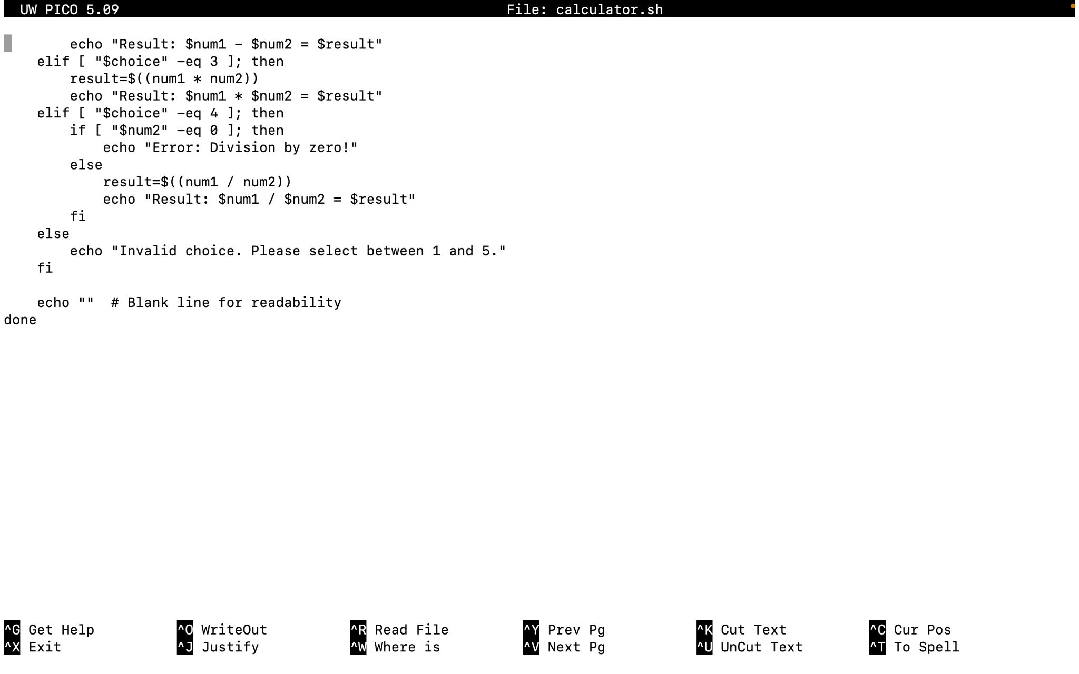

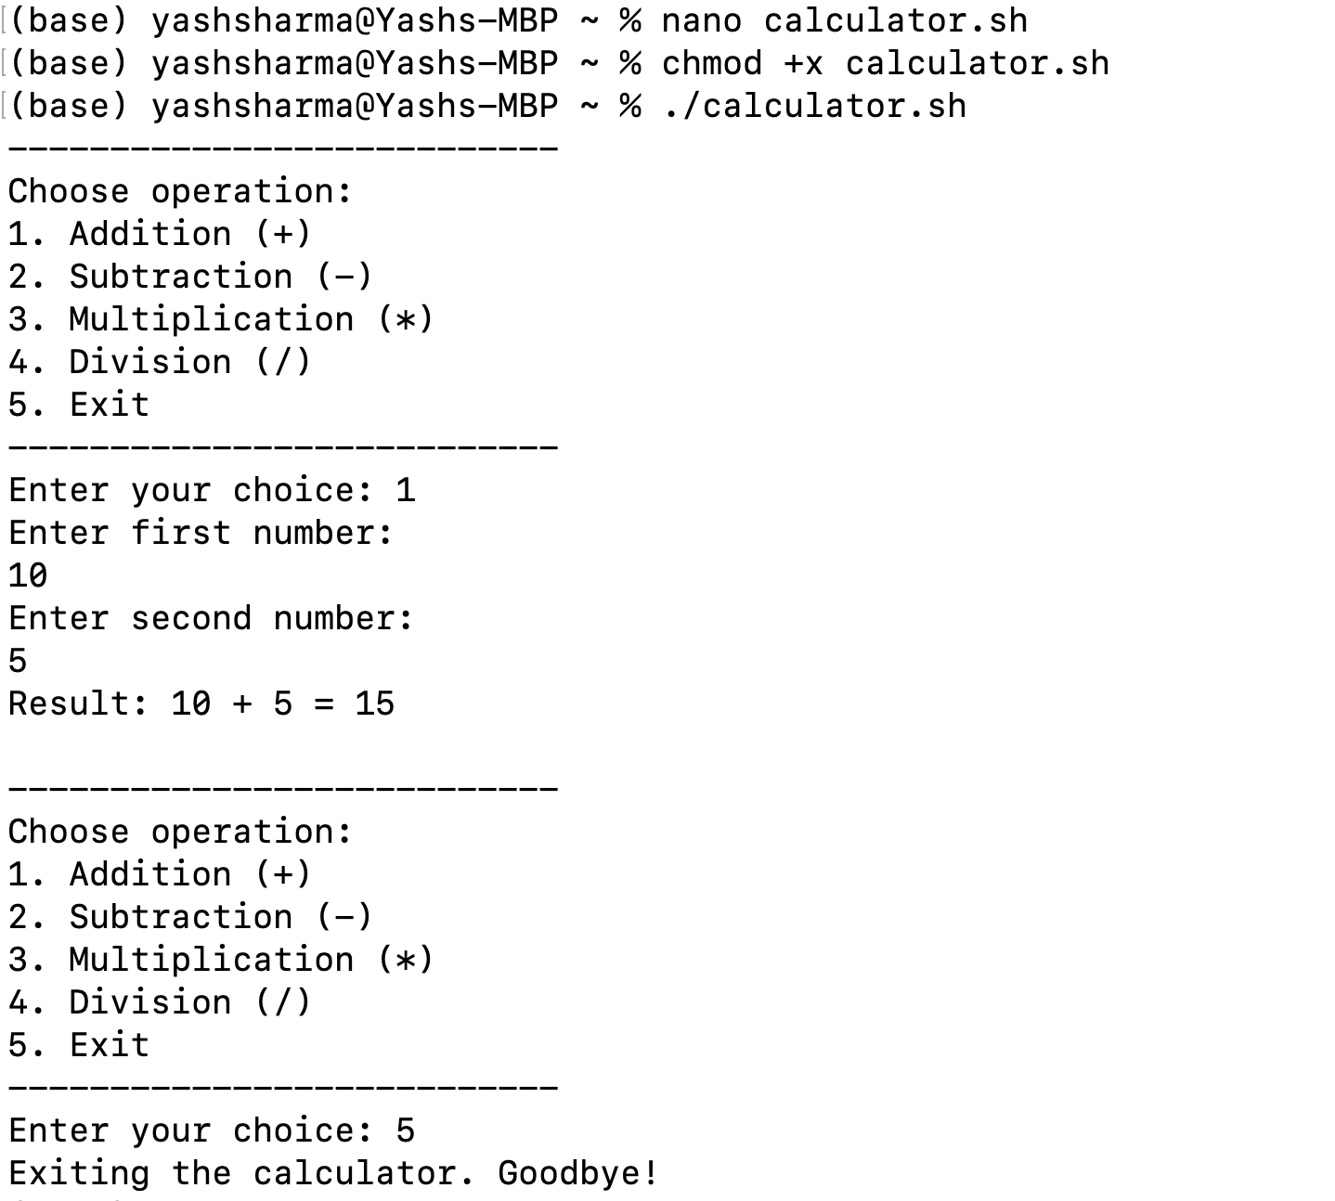

| DAY 4  #SQL queries  ALTER TABLE  CREATE DATABASE  CREATE TABLE  GROUP BY  INSERT INTO  Update  Delete  DROP TABLE  CREATE INDEX  ORDER BY  Select  ALTER DATABASE  DROP DATABASE  Exists  Today’s Practical Topics Covered   * Create a database * Create a table * Joining two tables * Importing csv file to the table * Using basic commands   The below query was to create the table    The query to add rows to the table    This query shows two things at a time firstly the engineering department view and then updates the salary of engineering department by 10 percent    The below query loads the csv file to the table    The CSV file below    The below is the csv file loaded into the table using the query LOAD DATA INFILE      The below query find the avg salary based on departments | |
| --- | --- |

**TASKS OF THE DAY:**

1. In a db you need to find all those people whose name is starting with S and ender with M
2. age >9 but <19

TASK 1

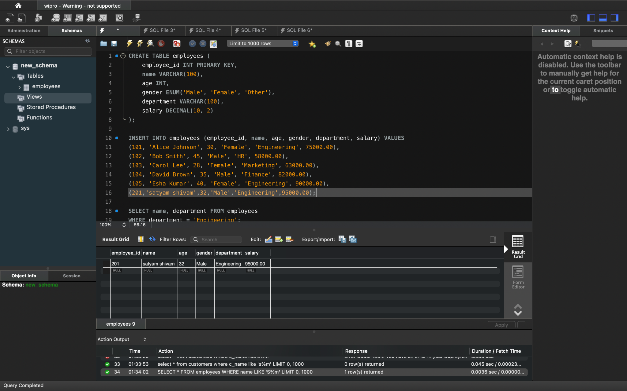

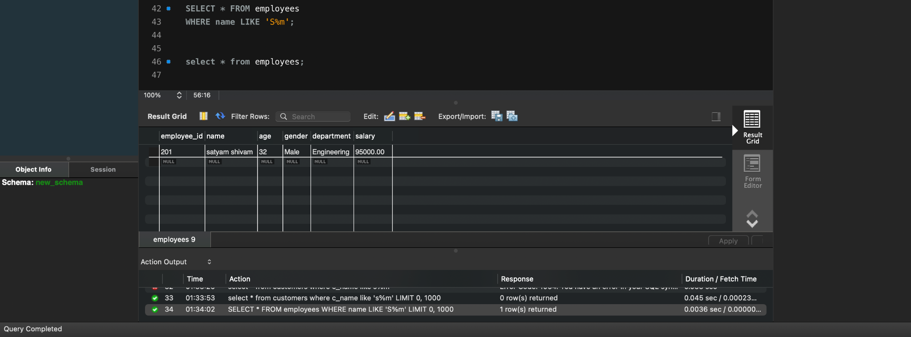

TASK 2

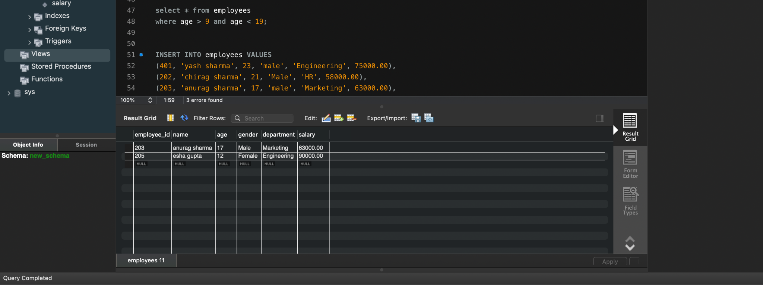

DAY 5

Advanced SQL

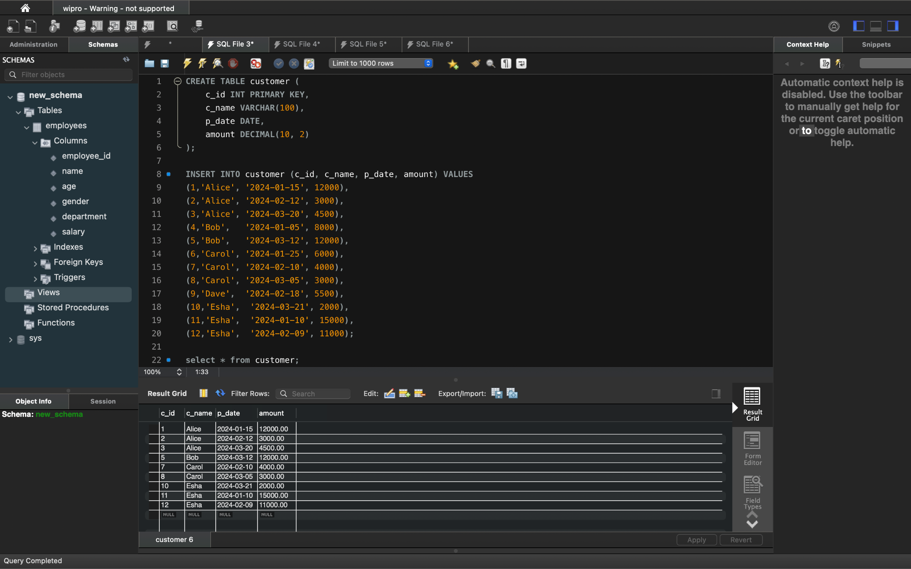

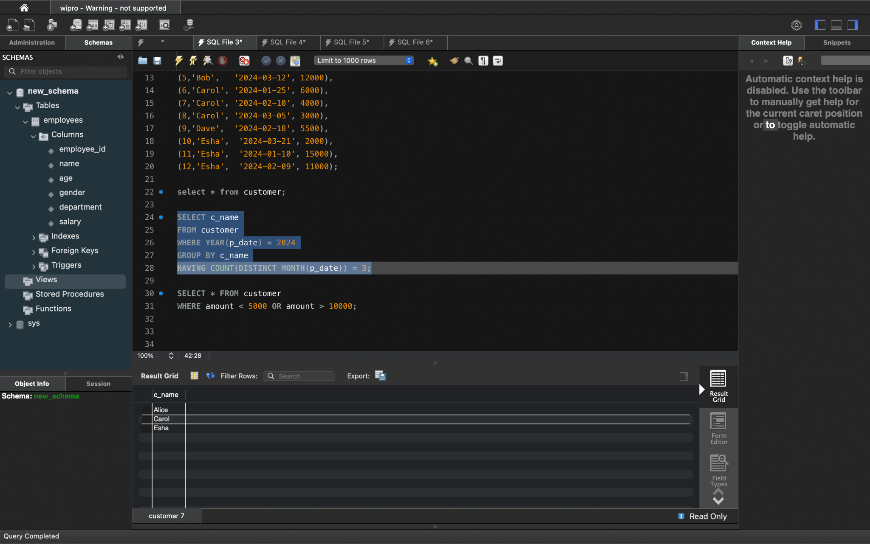

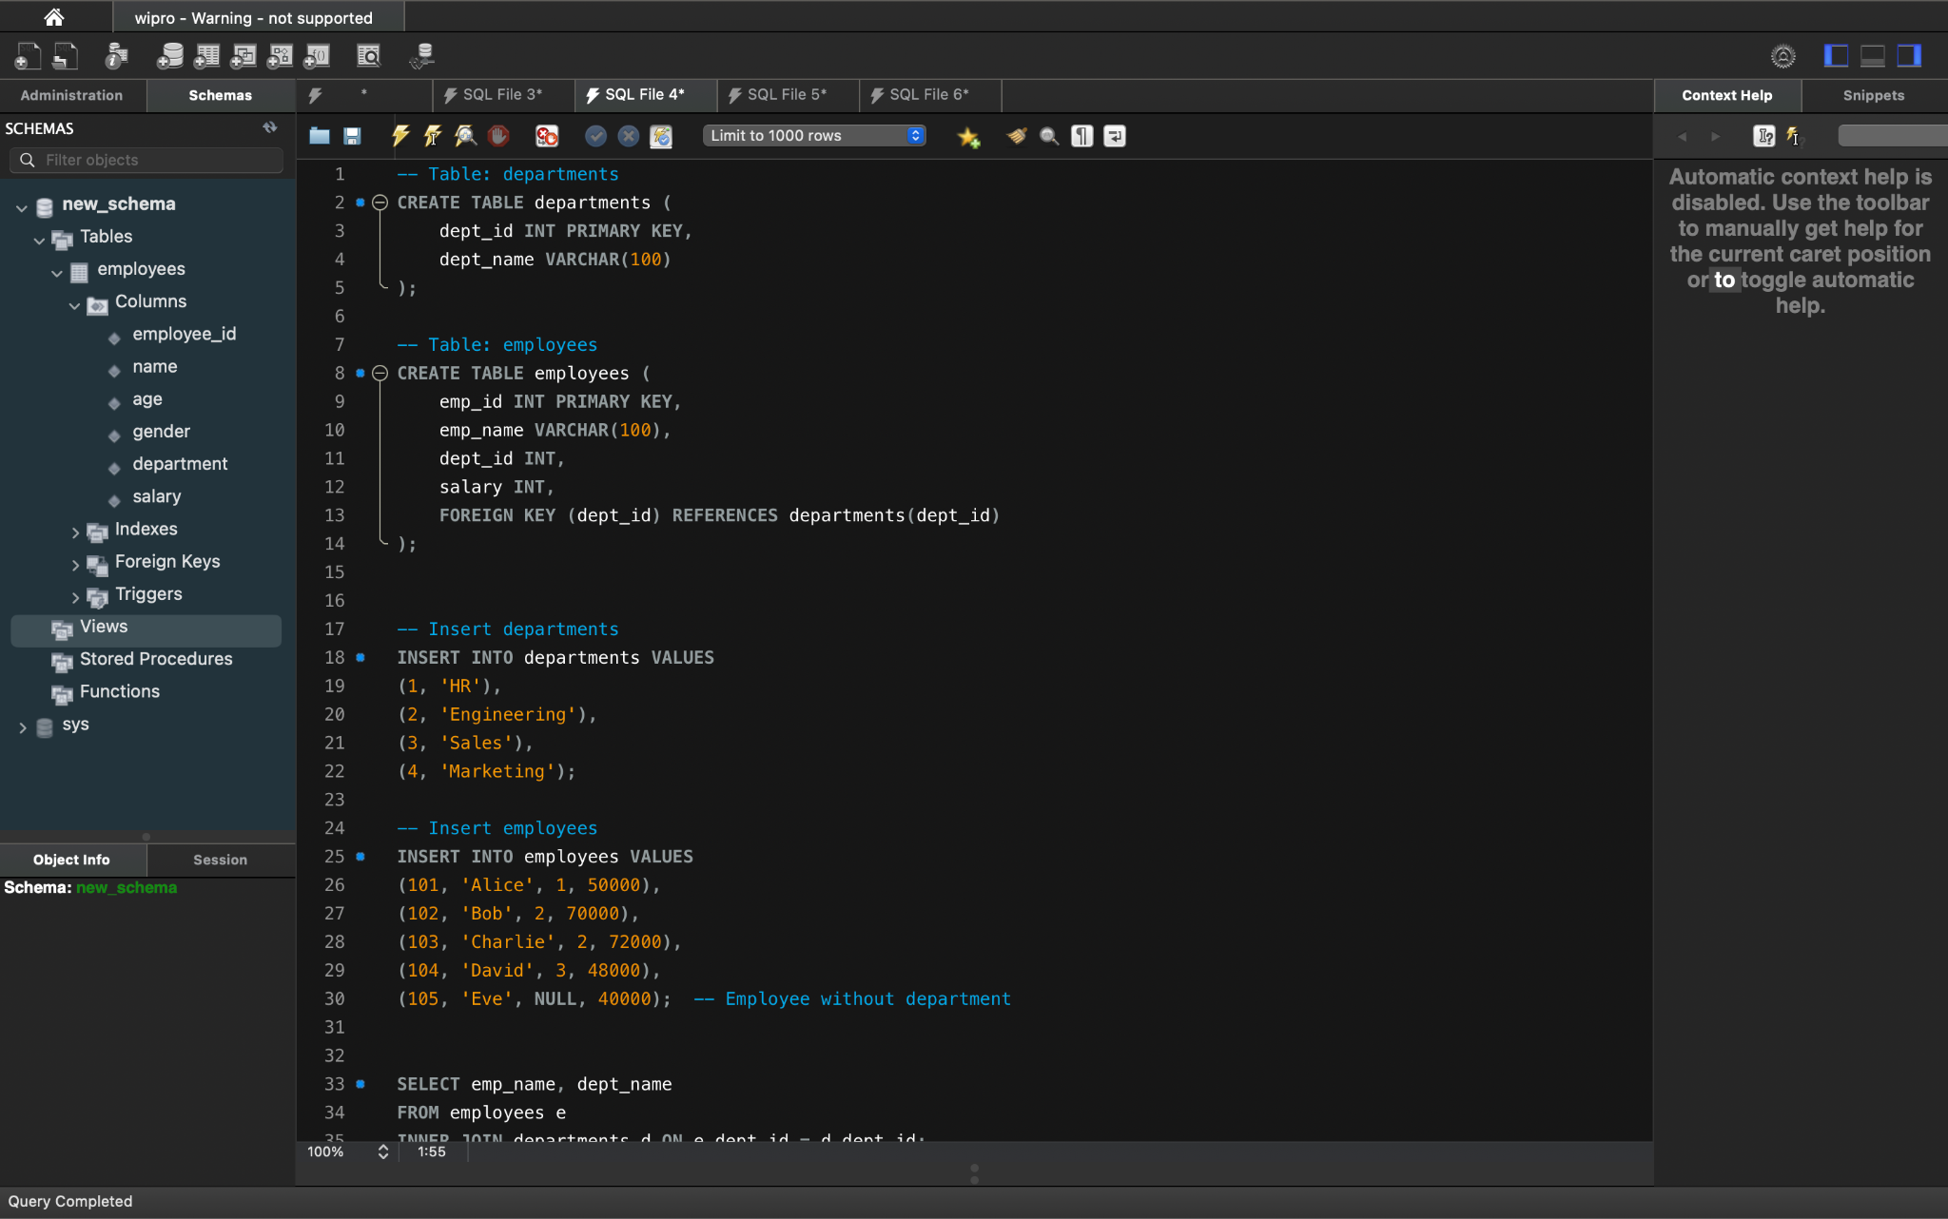

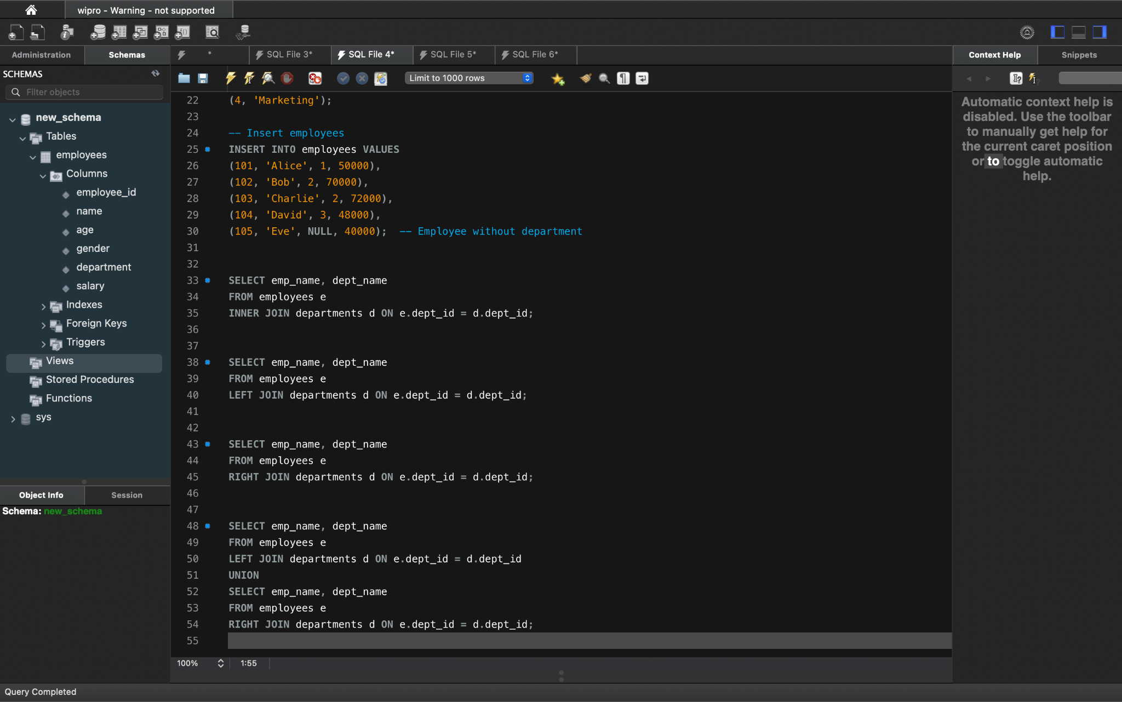

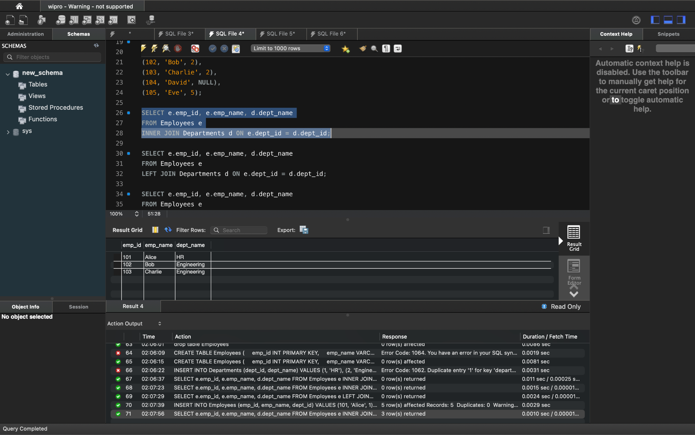

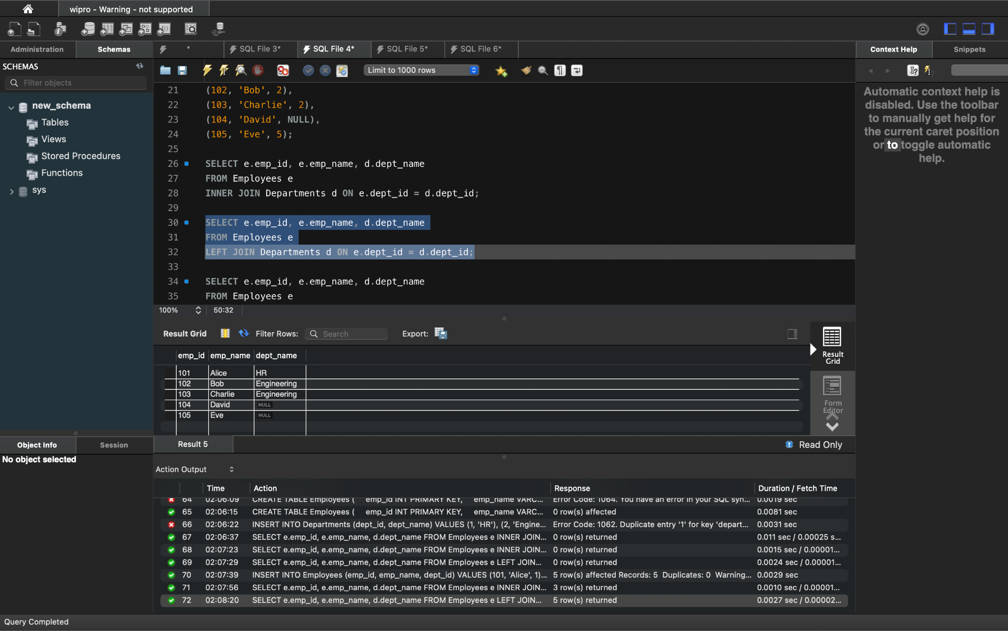

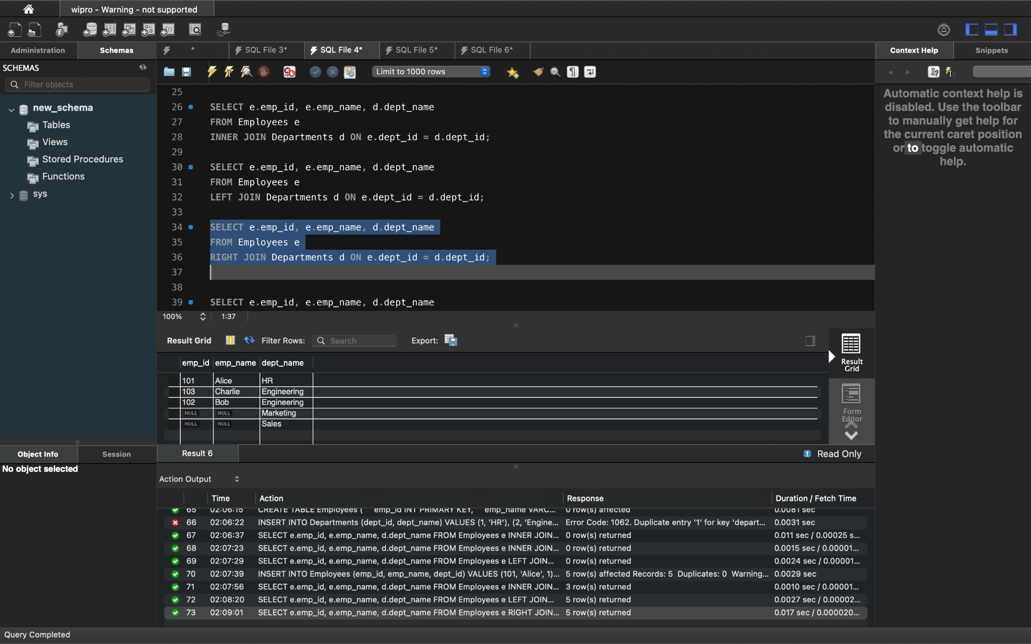

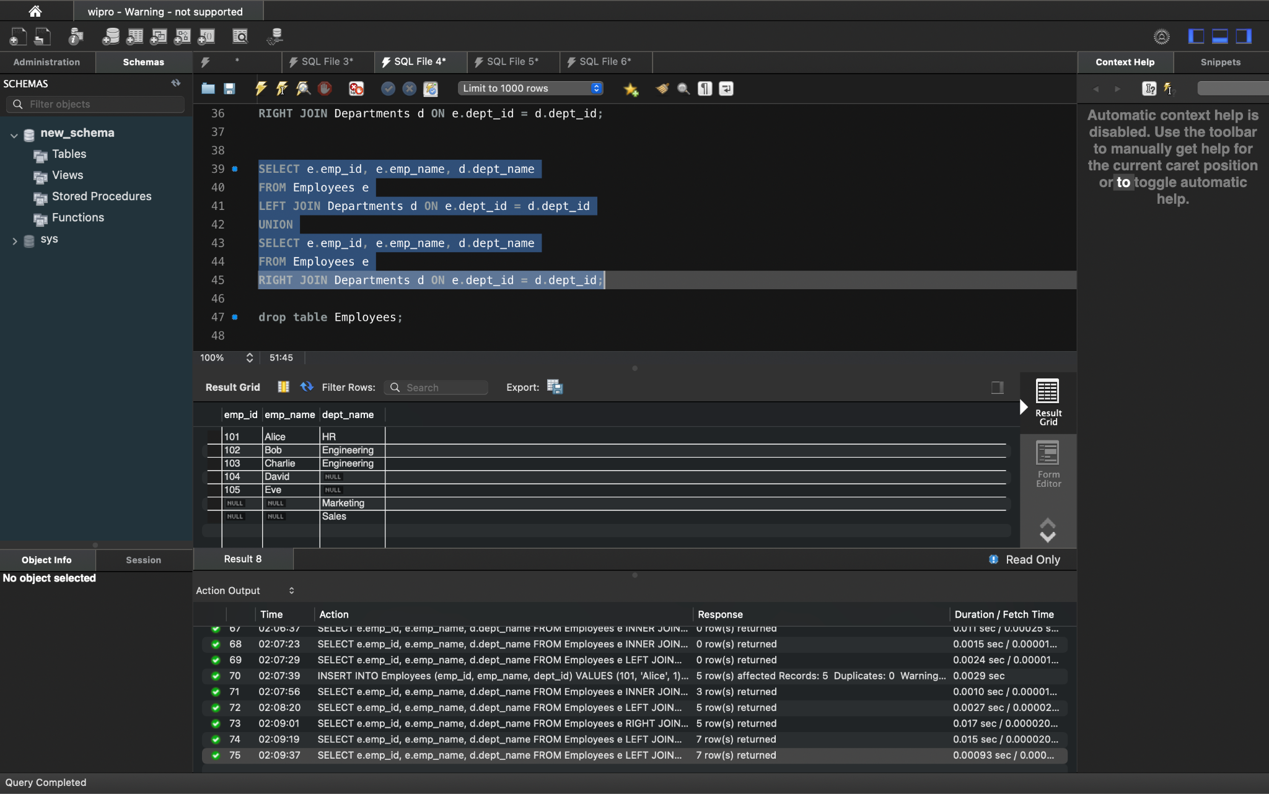

**TASKS OF THE DAY:**

Retrieve all the data of customers who ordered from the location delhi   
  
Two tables  
 1. Customers (C_id, name, City)

2. Orders(order_id, C_id, order_date)

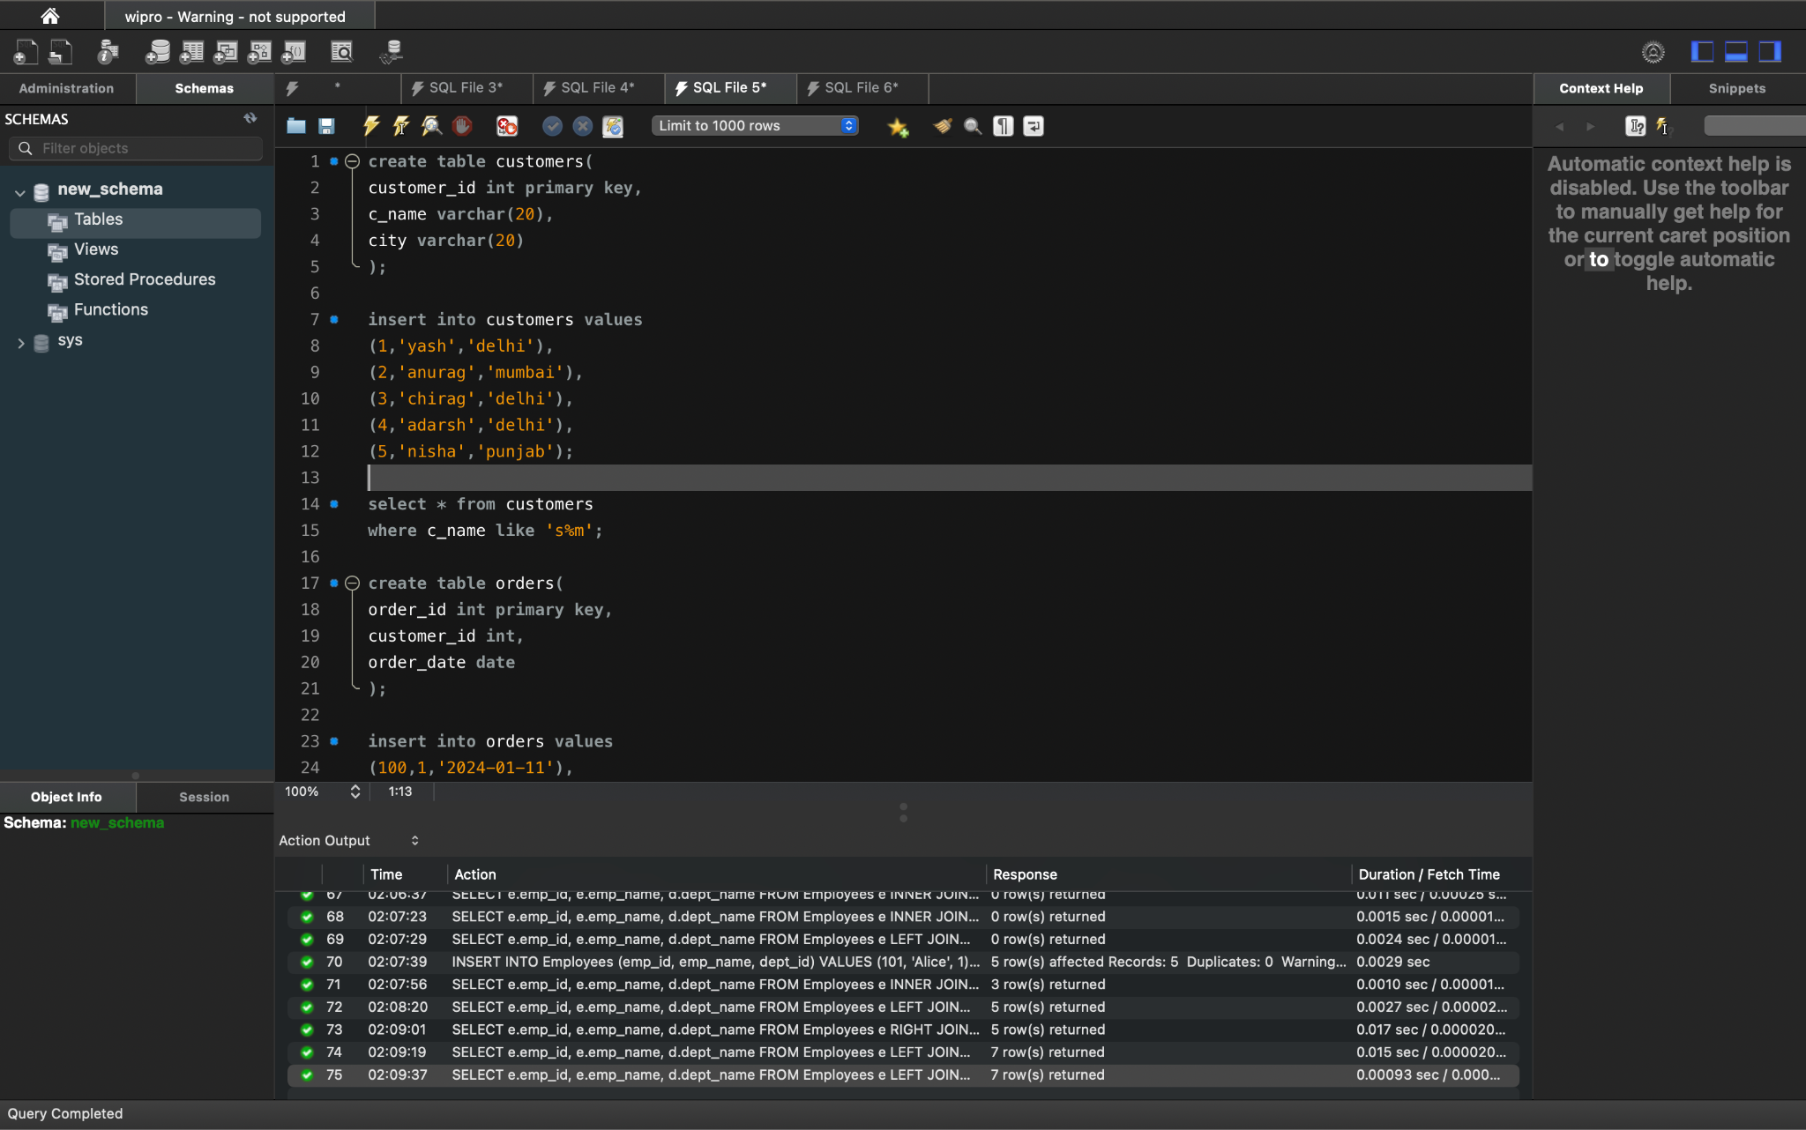

THE TWO TABLES ARE CREATED HERE

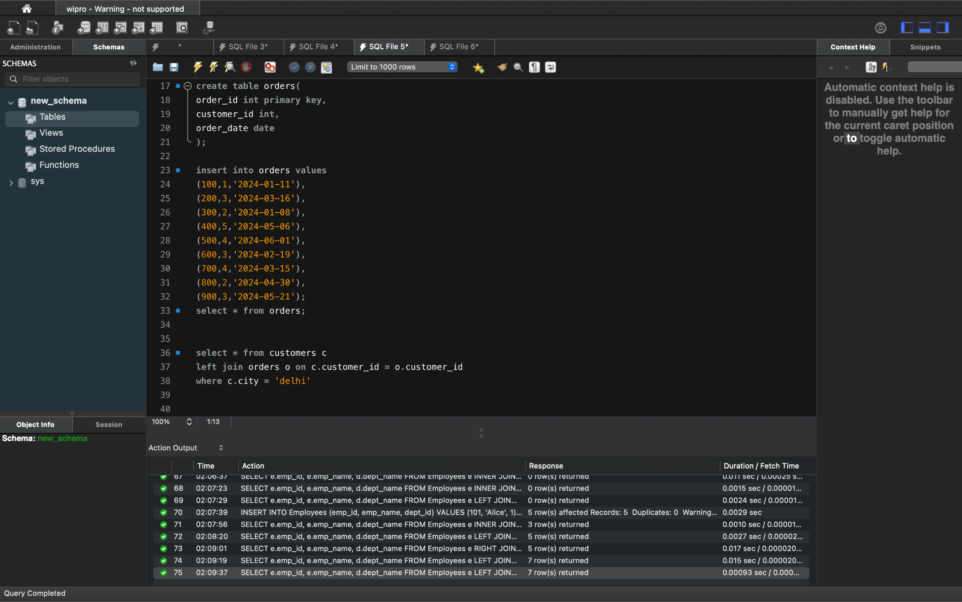

OUTPUT

